

|  |  |
| --- | --- |
|  | **imotion** |
|  |  |
|  | System Manager |
|  |  |
|  | Configuration and Usage |
|  |  |
|  | Technical Description |
|  |  |
|  | Version: 1.1 |
|  | State: Draft |
|  | Classification: Internal use only |
|  | Author: RAN |
|  | Creation date: 2012-08-20 |
|  | Repository: $/Gorba/Main/Motion/SystemManager/Documents/TD_AbuDhabi_SystemManager_Configuration and Usage.docx |
|  | Gorba AG  Sandackerstrasse  9245 Oberbüren  Switzerland |

**Table of contents**

1 Introduction 4

1.1 Scope 4

1.2 Intended Audience 4

2 Product Overview 4

2.1 System Overview 4

2.2 Applications Launched 4

3 Software Version and availability 4

4 Software Configuration 5

4.1 SystemManager.xml 5

4.1.1 <SystemManager> 6

4.1.2 <Launches> 6

4.1.3 <LaunchProcess> 7

4.1.4 <ExecutablePath> 7

4.1.5 <Arguments> 7

4.1.6 <Minimize> 7

4.1.7 <UseWatchdog> 7

4.1.8 <SplashFile> 8

4.1.9 <Destination> 8

4.1.10 <FileName> 8

5 Installation 8

5.1 Full installation 8

**Modification management**

|  |  |  |  |  |  |
| --- | --- | --- | --- | --- | --- |
| **Version** | **Date** | **Name** | **Dept.** | **Modifications** | **State** |
| 0.1 | 2012-08-20 | RAN | SW | Initial version | draft |
| 0.2 | 2012-09-12 | RAN | SW | Added the configuration for SplashFile | draft |
| 0.3 | 2012-09-12 | COS | SW | Specified the path for the latest delivered directory with binary files.  Checked the set of files required by SystemManager.exe | draft |
| 1.1 | 2013-03-08 | RAN | SW | Modified sections 1.1, 3.3, 4.1.7, 4.1.8 based on inputs by SEM | draft |

**Review**

|  |  |  |  |  |
| --- | --- | --- | --- | --- |
| **Version** | **Date** | **Name** | **Dept.** | **Remarks** |
| 0.3 | 2012-09-12 | COS | SW | ok |
|  |  |  |  |  |
|  |  |  |  |  |
|  |  |  |  |  |

**Release**

|  |  |  |  |  |
| --- | --- | --- | --- | --- |
| **Version** | **Date** | **Name** | **Dept.** | **Remarks** |
| 1.0 | 2012-09-12 | COS | SW | First release. |
|  |  |  |  |  |
|  |  |  |  |  |
|  |  |  |  |  |

# Introduction

## Scope

This document is a technical description of System Manager developed specifically for the Abu Dhabi project. This is different application from the System manager for Arriva project. This document gives the configuration and operation information about the System Manager for the Abu Dhabi project.

## Intended Audience

This document is written to be understood by Gorba staff familiar with Gorba products. Minimal technical skills are required.

# Product Overview

## System Overview

The System Manager is an application used to launch all the applications required for the Topbox to run. It acts as a watchdog for the applications launched. If an application closed, the System Manager detects the closure and launches that specific application again. The System Manager is launched by the Update application at the end of the update process.

## Applications Launched

The System Manager launches the applications specified in the configuration file “SystemManager.xml”.

# Software Version and availability

The latest delivered version of SystemManager.exe can be downloaded from the following path:

\\Softwareserver\Release\SW\02_imotion\02_TFT\12_SystemManager

The release directory contains the following binary and configuration files for the correct operation of System Manger application. It is essential to have the following files before using the application.

|  |  |
| --- | --- |
| **File** | **Description** |
| SystemManager.exe | This file launches in execution System Manager as a console application. All the logs produced during the System Manager activity can be viewed here (if enabled in NLog.config). |
| CommandLineParser.dll |  |
| Gorba.Common.Configuration.dll | Library containing the iMotion’s *engine* required to load configuration file. |
| Gorba.Common.Medi.Core.dll | Library for the communications with the Gorba’s server. |
| Gorba.Common.Util.dll | Library for common utilities required for the System Manager‘s execution. |
| Gorba.Motion.SystemManager.Core.dll | Library containing all the logic that effectively realizes the system manager launch process. |
| NLog.dll | Library that manages all the Protran’s log activities. |
| NLog.config | Configuration file for the Protran’s log activities. |
| medi.config | Configuration file to interact with the application called MediServer.exe |
| SystemManager.xml | Configuration file for the System Manager’s execution. |
| Microsoft.Practices.ObjectBuilder2.dll |  |
| Microsoft.Practices.ServiceLocation.dll |  |
| Microsoft.Practices.Unity.dll |  |

# Software Configuration

## SystemManager.xml

The SystemManager.xml is the configuration file for the System Manager. It consists of the configuration to launch and control certain features of the applications launched. Below is an example of the SystemManager.xml file

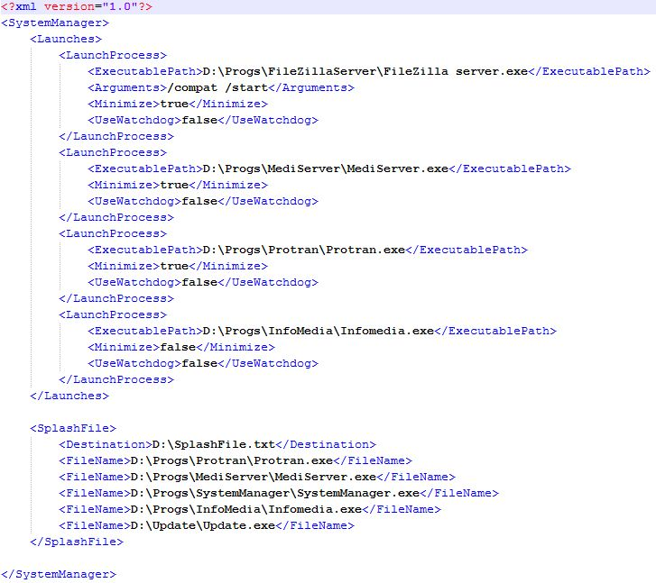

Figure 4‑1 SystemManager.xml example

Below is the description of the tags specified in the configuration file:

### <SystemManager>

This is the root of the document.

|  |  |  |  |
| --- | --- | --- | --- |
| **Tag’s attributes** | **Mandatory** | **Tag’s Meaning** | **Values admitted (default value)** |
| No | Yes | Just the container of all the other tags. | No value. Only its allowed sub-tags. |

Figure 4‑2 SystemManager tag

The sub-tags allowed are:

* <Launches> (only one is accepted)
* <SplashFile> (only one is accepted)

### <Launches>

|  |  |  |  |
| --- | --- | --- | --- |
| **Tag’s attributes** | **Mandatory** | **Tag’s Meaning** | **Values admitted (default value)** |
| No | Yes | This XML tag contains the set of processes to be launched. | No value. Only it’s allowed sub-tags. |

Figure 4‑3 Launches Sub-Tag

The sub-tags allowed are:

* <LaunchProcess> (multiple tag of this type are allowed)

### <LaunchProcess>

|  |  |  |  |
| --- | --- | --- | --- |
| **Tag’s attributes** | **Mandatory** | **Meaning** | **Values admitted (default value)** |
| No | Yes | Contains information of the executable path for the application to be launched and its attributes. | No value. Only it’s allowed sub-tags. |

Figure 4‑4 LaunchProcess Sub-Tag

The sub-tags allowed are:

* <ExecutablePath> (only one is accepted)
* <Arguments> (only one is accepted)
* <Minimize> (only one is accepted)
* <UseWatchdog> (only one is accepted)

### <ExecutablePath>

|  |  |  |  |
| --- | --- | --- | --- |
| **Tag’s attributes** | **Mandatory** | **Tag’s Meaning** | **Values admitted (default value)** |
| No | Yes | Contains the path of the application to be launched. | A string. |

Figure 4‑5 ExecutablePath Sub-Tag

### <Arguments>

|  |  |  |  |
| --- | --- | --- | --- |
| **Tag’s attributes** | **Mandatory** | **Tag’s Meaning** | **Values admitted (default value)** |
| No | No | Contains the arguments used for the launch of the application. | A string. |

Figure ‑6 Arguments Sub-Tag

### <Minimize>

|  |  |  |  |
| --- | --- | --- | --- |
| **Tag’s attributes** | **Mandatory** | **Tag’s Meaning** | **Values admitted (default value)** |
| No | Yes | Tells if the application launched should be minimized upon launch or not. | The strings “true” or “false”.  Default value “true”. |

Figure ‑7 Minimize Sub-Tag

### <UseWatchdog>

|  |  |  |  |
| --- | --- | --- | --- |
| **Tag’s attributes** | **Mandatory** | **Tag’s Meaning** | **Values admitted (default value)** |
| No | Yes | Tells if the application launched has a watchdog check. | The strings “true” or “false”.  Default value “false”. |

Figure ‑8 UseWatchdog Sub-Tag

The watchdog for an application started by System Manager checks if an application is running and restarts it.

### <SplashFile>

|  |  |  |  |
| --- | --- | --- | --- |
| **Tag’s attributes** | **Mandatory** | **Tag’s Meaning** | **Values admitted (default value)** |
| No | Yes | This XML tag contains the set of fullpath of filenames whose version number is to be displayed | No value. Only it’s allowed sub-tags. |

Figure 4‑9 SplashFile Sub-Tag

The sub-tags allowed are:

* <Destination> (only one is accepted)
* <FileName> (multiple tag of this type are allowed)

The Splash file is created by the System Manager when it is launched with the filename given by the value of the tag “Filename” and the destination of the file given by the tag “Destination”. The file contains the version information of all the applications listed in SystemManager.xml. If the version information or file is not available, then “n/a” is the value shown for that application.

### <Destination>

|  |  |  |  |
| --- | --- | --- | --- |
| **Tag’s attributes** | **Mandatory** | **Tag’s Meaning** | **Values admitted (default value)** |
| No | Yes | Contains the path of the SplashFile.txt. | A string |

Figure ‑10 Destination Sub-Tag

### <FileName>

|  |  |  |  |
| --- | --- | --- | --- |
| **Tag’s attributes** | **Mandatory** | **Tag’s Meaning** | **Values admitted (default value)** |
| No | Yes | Contains the path of the file whose version should be displayed on Infomedia | A string |

Figure 4‑11 FileName Sub-Tag

# Installation

## Full installation

The application System Manager is installed using the Update application. Please refer to the document “TD_AbuDhabi_Update_Installation.docx” for the steps of installation.